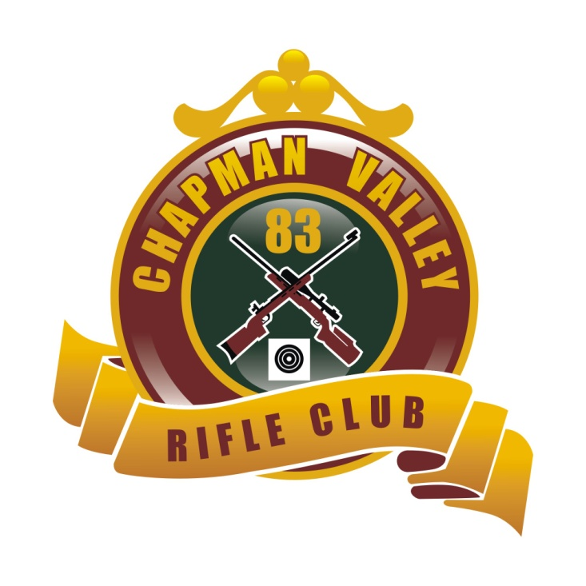

CHAPMAN VALLEY RIFLE CLUB
PICNIC SHOOT
28th & 29th of July 2018
Come one come all to Chapman Valley’s Annual Picnic Shoot. Electronic Targets to be used.
SATURDAY: 2 x 10 Shot 300y Starting time 12:00. Muster 11:45
SUNDAY: 2 x 10 Shot 500y, 1 x 15 Shot 600y Time permitting. Starting Time 08:00. Muster 07:45
ENTRY FEE $80
Sunday only (no Trophies) $50. Divisions decided by numbers.
PROPOSED T/R 3 DIV’s F/Class (STD) 2 DIV’s
F Open 1 Div FTR 1 Div
Daily Range Money to be won in all Divisions.
Entry fee covers Saturday night’s dinner, Sunday morning breakfast, Lunch and afternoon tea. Saturday day lunch, gold coin donation.
Camping on range, full toilet and showering facilities, BYO Generator.
Bar facilities
AMMO AVAILABLE
Further info please call Colin Dewar 0484705855, Bruce Alden 0447887577, Ray Brooks 0429311010

